Project: Event Registration Platform

Description: I have developed an event registration platform that allows users to create and manage events. Users can register for events, and manage their events, including attendee lists and event details. An admin user has the authority to manage all events and users.
Architecture

The project is organized as follows:
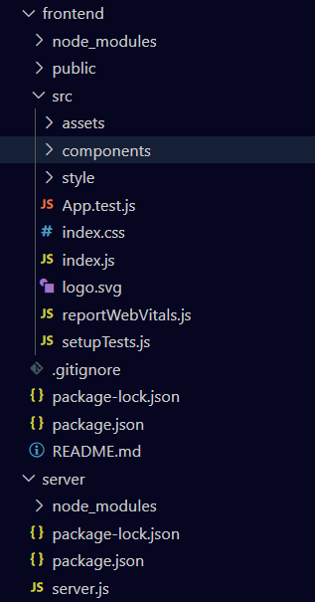

Inside the “frontend” folder, is the ‘react’ app which, is responsible for handleing the front front-end of the page.The folder ‘assets’ holds all the templates for the platform. The folder ‘components’ holds all the Navbars (one for the user and one for the admin). The folder “styles ” holds all the .css modules.

Assets
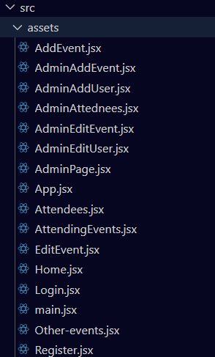

Components
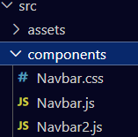

Style

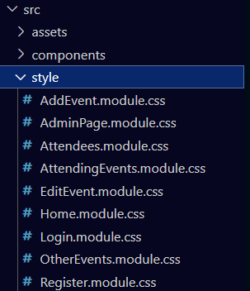

Inside the server folder, are the platform components responsible for the back-end of the platform. Specifically the ‘server.js’ file.

Technology:
- React
- Node.js
- Express
- Bcrypt
- React
- Router
- Axios
- JSON Web Tokens (JWT)
- MySql database

Usage Guide:

- Through terminal, go to the server folder using ‘cd server’ .
- Use ‘npm start’ on the same terminal to run the server.
- ON another terminal, go to the frontend folder using ‘cd frontend’.
- On that terminal, use ‘npm start’ to run the front-end react app. Once the frontend starts, you will be immidietly redirected to the platform.
If done correctly, you will be redirected to ‘http://localhost:3000/login’.

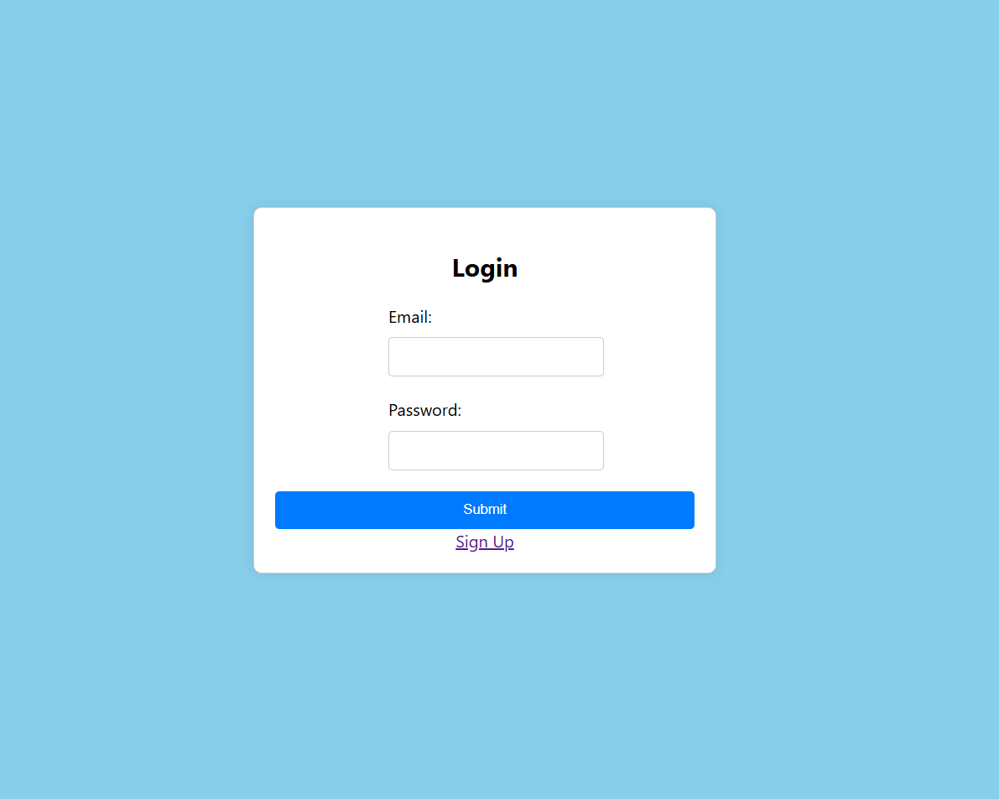

Once on the log in page, you can chose to sign up, which will redirect you to “https://localhost:3000/register”.

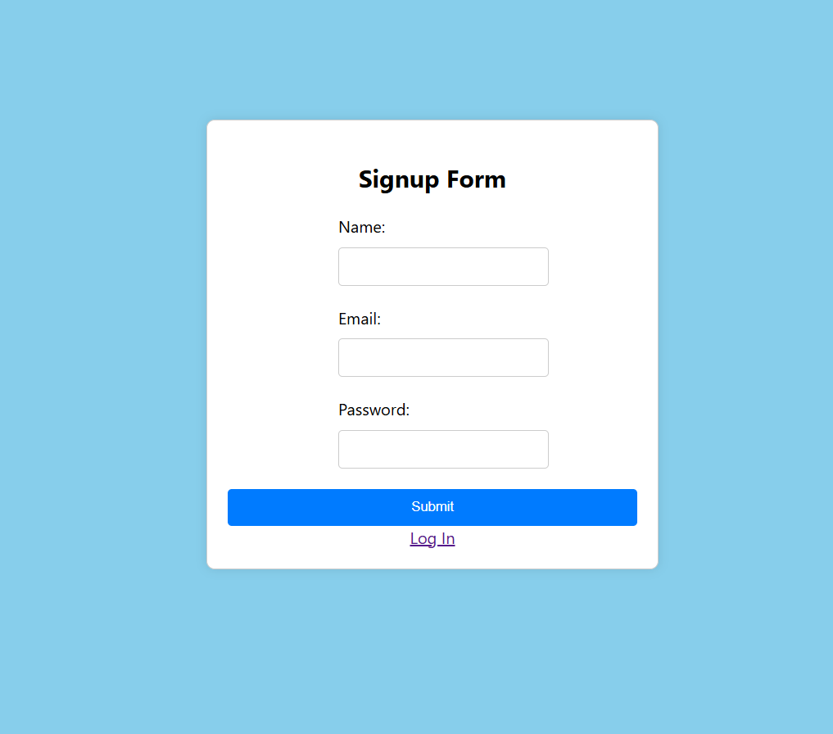

After signing up, you will be redirected to the log in page again, where you can put your email address and password to log in and get access to the platform.

When signing in, the data goes from the front-end, to the back-end, where the password gets encrypted using bcrypt, and then the user information gets uploaded to the database after pressing submit. When submit is pressed on the log in page, after imputing your email and password, the submitted information, goes to the back-end, where email and password is checked in the database if they exist and if they are correct. Since the password is encrypted, it is compared using ‘bcrypt.compare()’.

After everything is done correctly, you will get access to the home page ‘http://localhost:3000’/’ which is the platforms main page.

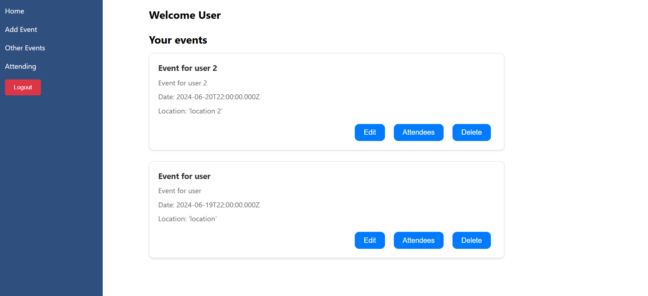

On the left is the user navbar. The links are: Home, which redirects you to “http://localhost:3000” where all the events where organizer_id corresponds with the user_id of the lged in user;Add Event which redirects to “http://localhost:3000/add-event”, which is a form that after being filled correctly, and pressing submit, uploads the data to the database and then redirects you to “http://localhost:3000”; Other Events which redirects you to “http://localhost:3000/other-events” where events from other users are displayed, on each event is a button that reads “Attend”, which turns green if the user is already attending , and if pressed, it adds to the attendees list the event_id of the event youre attending, and your user_id (the id of the user thats loged in); Attending which redirects you to “http://localhost:3000/attending” which displays al lthe events the user is attending. You can press Remove Attendance, to remove the user_id(of the logged in user) and the event_id (of the clicked event) from the attendees list.

“http://localhost:3000/add-event”
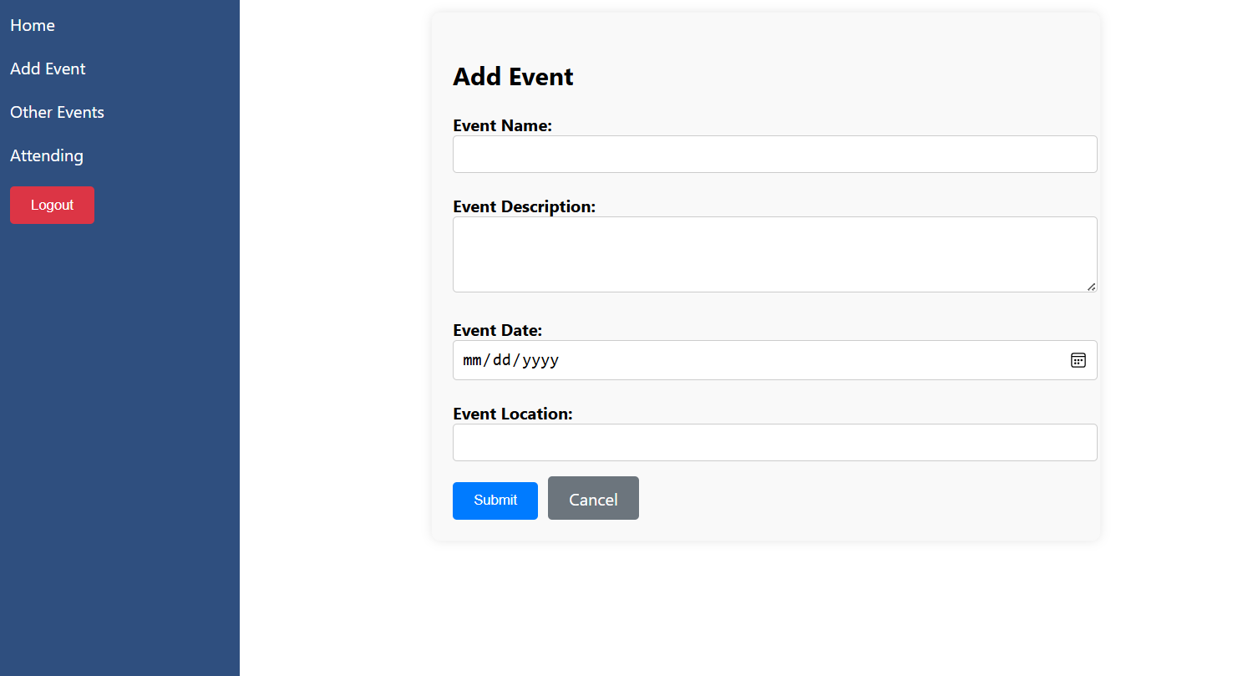

“http://localhost:3000/other-events”
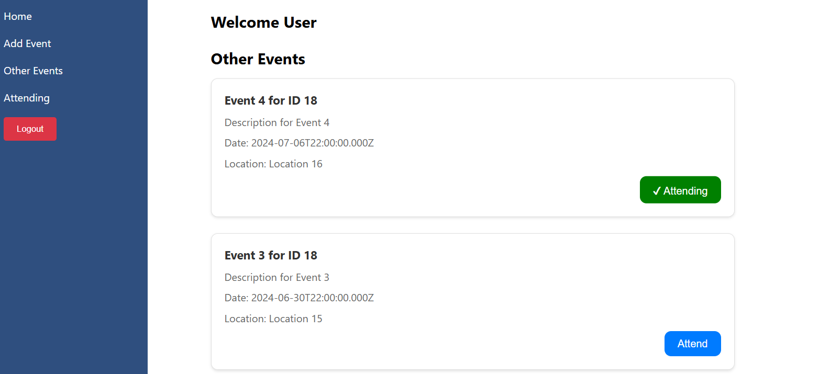

“http://localhost:3000/attending”
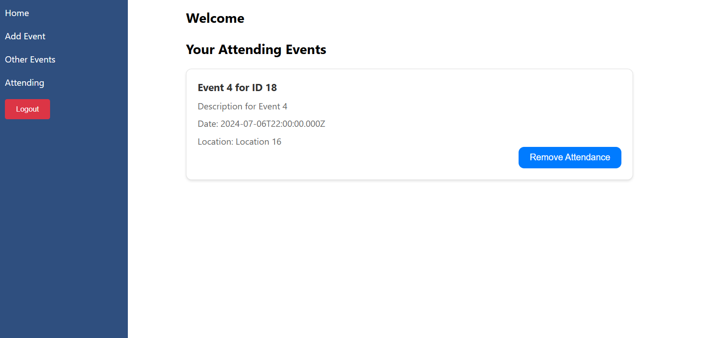

On “https://localhost:3000/” you see 3 buttons per events. The buttons are:
- Edit, which redirects you to “https://localhost:3000/edit-event/event_id”,which contains a form filled with the information of the event you are editing. After changing the details of the event, you can click the Save Changes button, which will turn green and update the event details on the database.
- Attendees, which redirects you to “https:localhost:3000/attendees/event_id”, which contains a list of the users attending the event. Beside them is a button that says Remove. After clicking it it removes the attendee from the attendee table.
- Delete, which deletes the event from the events table, alongside the attendees on the attendees table.

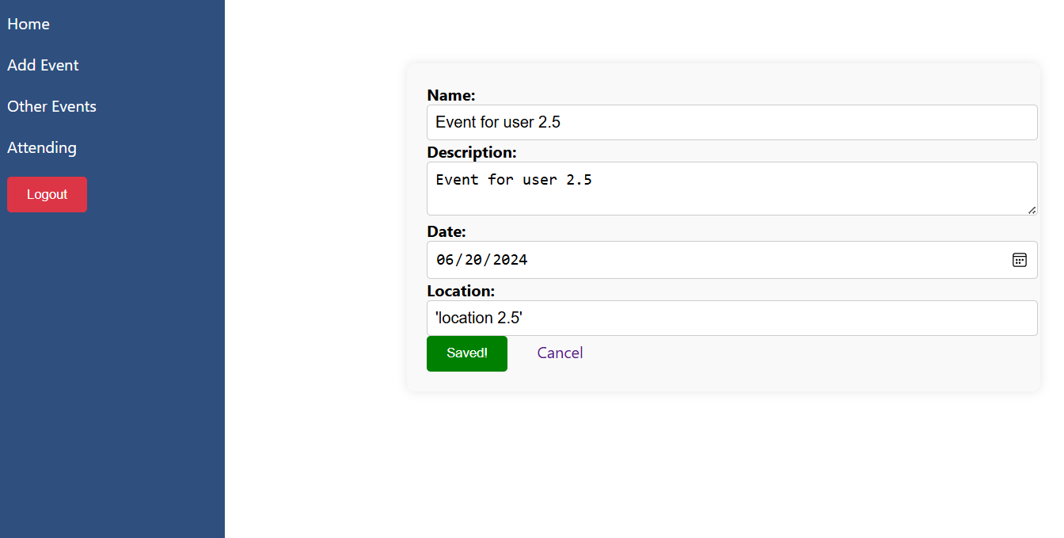
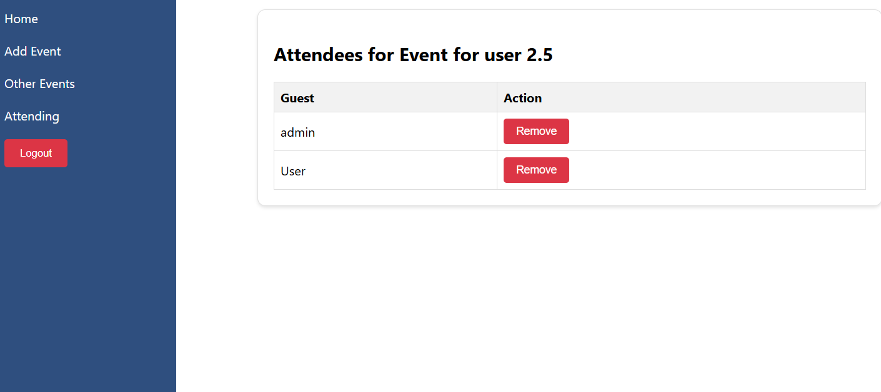
‘https://localhost/attendees/159’

If the user has the ‘admin’ role in the users table, the user will instead be redirected to ‘https://loclahost:3000/admin’, which displays all users and all events, alongside the admin navbar which contains links to ‘https://localhost/admin/add- event’ and ‘https://localhost/admin/add-user’.

‘https://localhost:3000/admin’
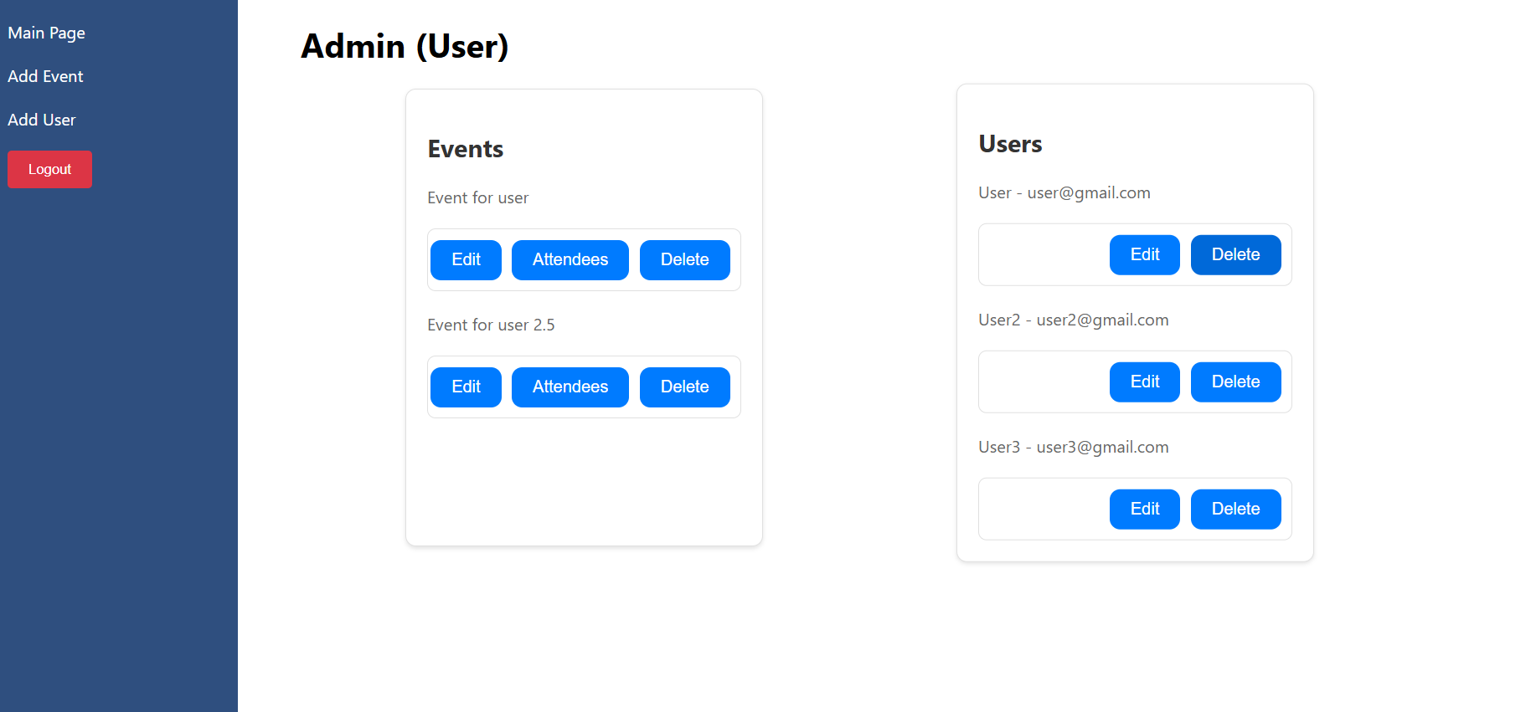
On the events side, we can see the name of the event and 3 buttons per event: Edit, which redirects you to ‘http://localhost:3000/admin/edit-event/event-id’, which contains a form where you can edit the event details, including the event organizer;Attendees which displays redirects you to ‘https://localhost:3000/admin/attendees/event-id’ which contains a list of the attendees for the event, which a button that allows you to remove attendee from the attendee table; and delete which allows you to delete the event from the events table.

‘http://localhost:3000/admin/edit-event/event-id’
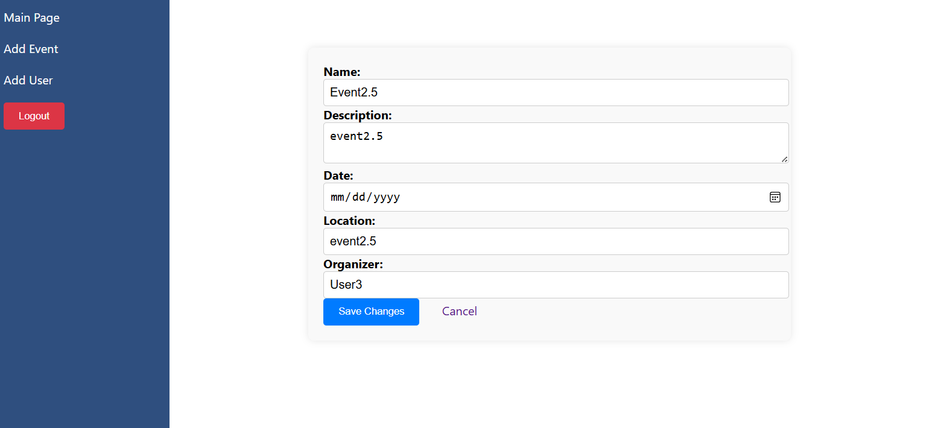

‘https://localhost:3000/admin/attendees/event-id’

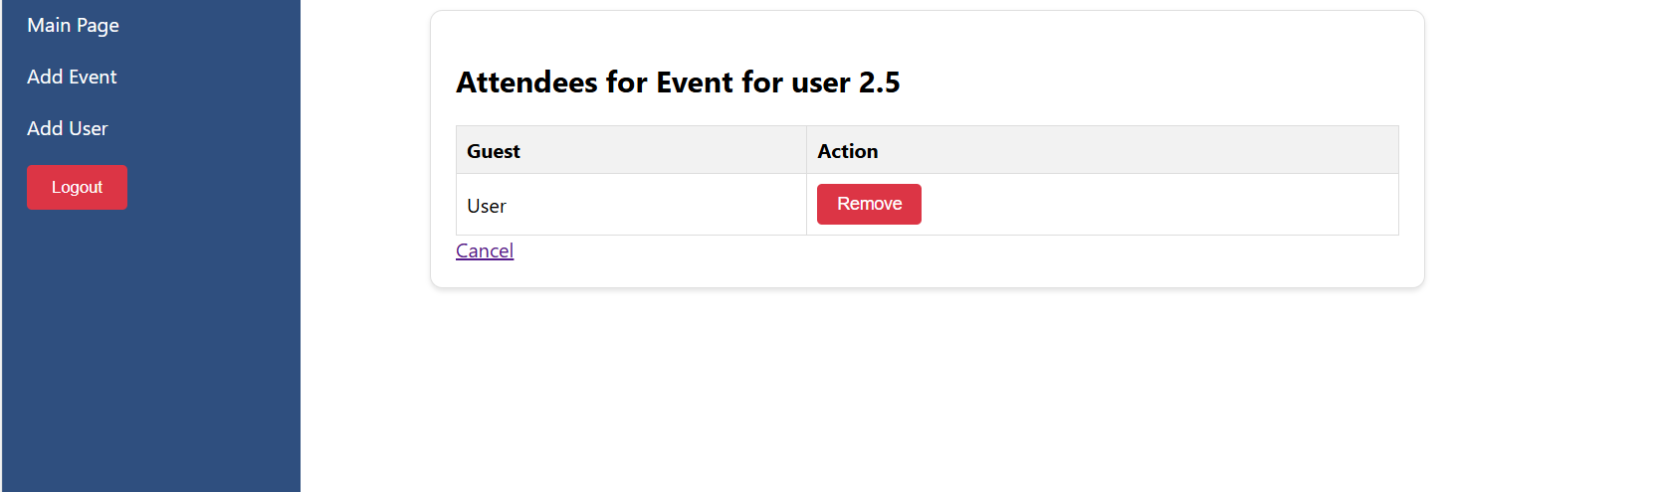

‘https://localhost:3000/admin/add-event’

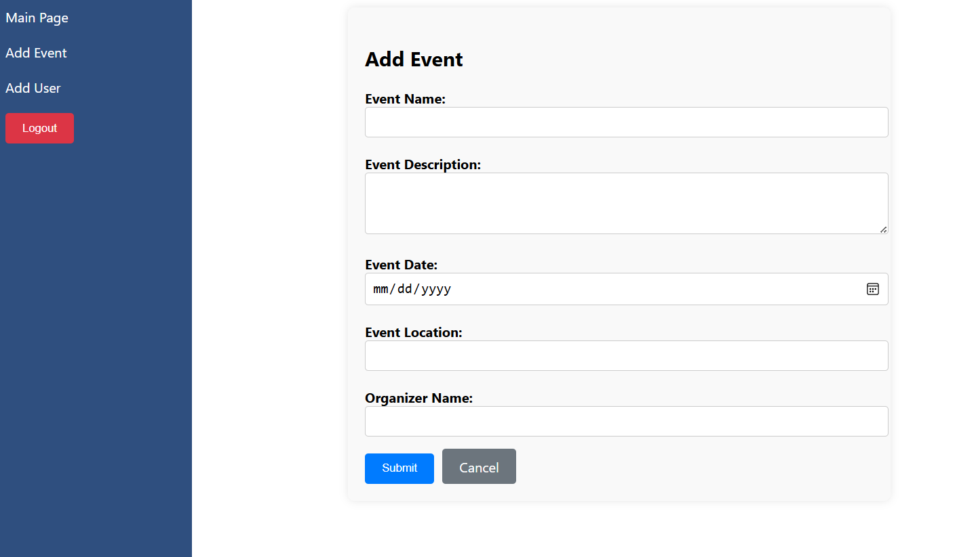
;

‘https://localhost:3000/admin/add-user’

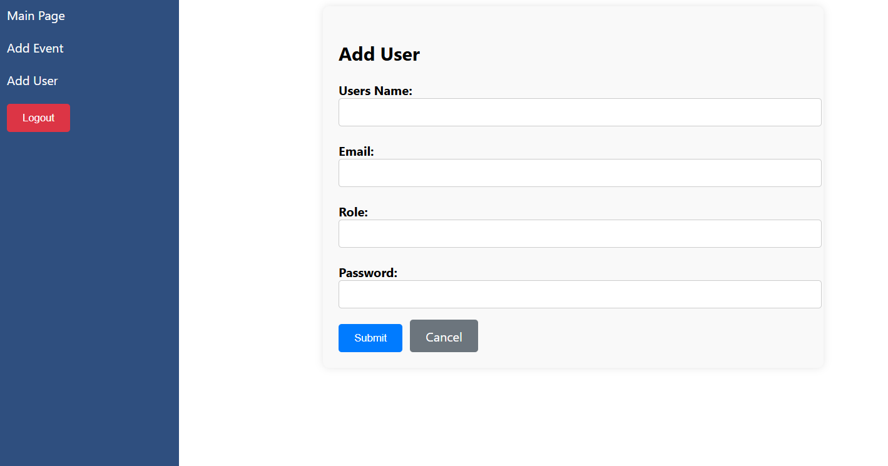
;

On the users side, you can see 2 buttons, edit and delete. Edit redirects you to “https://localhost:3000/admin/users/user_id”, which contains a form that allows you to edit the users information, including their role, which if its put as admin, gives the user admin privileges. The delete button deletes the user and their events.

“https://localhost:3000/admin/users/user_id”




